AZEdNews Articles

MCC BESTOWS TWO 2022 OUTSTANDING ADJUNCT

FACULTY AWARDS
OCTOBER 25, 2022 |  DAWN ZIMMER | MESA COMMUNITY  COLLEGE |  |  →  A A A
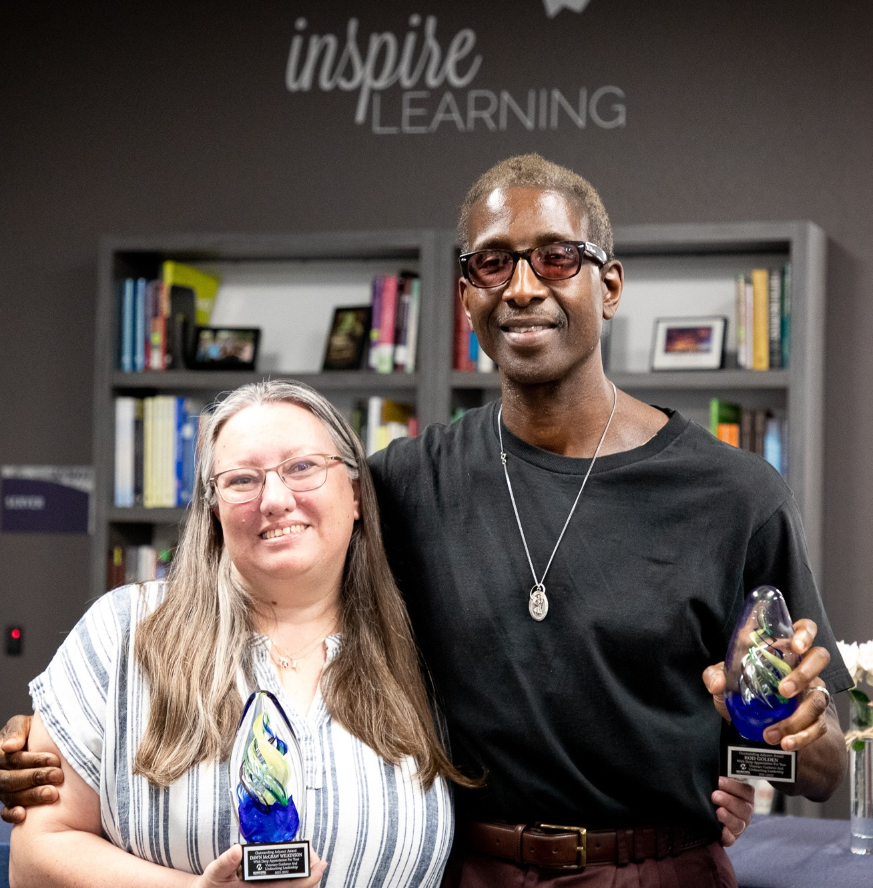
MCC 2022 Outstanding Adjunct Faculty: Dawn Wilkinson (left) and Rod Golden (right).
Mesa Community College selects Cultural Science Department Professor
Rod Golden and Education Studies Department instructor Dawn McGraw Wilkinson as Outstanding Adjunct Faculty Award recipients for 2022.
“I am honored to be recognized by my colleagues for the work I’m doing at MCC,” said Golden, who has taught at the college for nearly 17 yearsAZEdNews Article_{s}. “As an educator, I have three philosophies: First, students must exercise their intelligence. Second, if you as an educator are motivated to teach, your students will be motivated to learn. Third, if you love education, it will love you back.”
Golden, whose research is primarily in deviant behavior, gender studies, human sexuality and racial and ethnic relations; teaches sociology, race and ethnic relations, gender studies, sports in society and AfricanAmerican studies at MCC. For the past four years, he has led a series of regularly scheduled student focus groups dealing with topics such as anxiety, depression, stalking, cyberstalking and rape culture, to which Golden feels college students are particularly vulnerable because of their connectivity. “I want to give individuals who have been through these situations an open platform where they can share their experiences,” noted Golden, who teaches at both MCC Campuses.
Career highlights include experience as the coordinator of G.E.D. programs with emphasis on adults obtaining their high school diploma and as a community liaison administering mental health services for clients who were incarcerated in the prison system with their home community. His research has primarily been in deviant behavior, gender studies, human sexuality and racial and ethnic relations.
Wilkinson teaches and coordinates the Early Childhood Education program. “I am humbled to be one of two receiving this recognition from the incredible pool of adjuncts at MCC,” said Wilkinson. “Receiving an honor due to the work that I do with the students and my colleagues validates my passion and commitment to the program.”
An MCC adjunct faculty member for 11 years this fall, Wilkinson was selected, in part, for her work providing learning opportunities to her Early Childhood colleagues enhancing their ability to embrace and effectively use technology during the COVID-19 pandemic. As a peer coach for all adjunct faculty in the program, Wilkinson led technology coaching sessions for program students to assist them with courserelated technology needs. In addition to her MCC responsibilities, Wilkinson works full-time at Central Arizona College directing the First Things First Professional REWARD$ grant program, a nancial incentive for early childhood educators.
Over the past 25 years, Wilkinson has advocated for early childhood education. Her roles include being a preschool teacher, director, grant reviewer, Early Childhood Professional Development System specialist
and the executive director of the Arizona Association for the Education o^{AZEdNews Articles} f
Young Children. She supports the early childhood higher education community within the state by co-leading work to align content and develop shared outcomes for courses. Wilkinson also led the Maricopa County Community College District’s early childhood education programs through the national accreditation process for the National Association for the Education of Young Children.
“The recognition of our adjunct faculty is so important,” said Tim Kaufman, MCC Business Department faculty in fashion design and merchandising, and a 2021 adjunct faculty awards winner who organized the awards selection process this year. “An exceptional education happens when students and their instructors feel connected and included in the classroom.”
Kaufman, who is also an MCC alumnus, said the award recipients were selected using a scoring assessment of the information provided by the nominators. Volunteers involved in the selection process included Kaufman, Cultural Science Department adjunct faculty member Casiana
Pascariu, residential faculty member in the Social Sciences Department Sylwia Cavalcant and Cultural Science Department adjunct faculty member Nicole Bruno.
Honorable mentions include Patricia Avila, Reading Department; Jim
Bley, Stacey Nordhues and Jennifer Robinson, Communication, Theatre &
Film Arts; Bryce Bickham and Cameron Terrill, Music; Mike Brown, Life
Science; Andrea Carl and Natasha Murdock, English; Chris Glover,
Business; Sheba Jones and Jamie Tate, Allied Health; David Levy,
Computer Information Services; Jennifer Moyer, Robert Ratliff and Henry
Staggs, Applied Sciences & Technology; Darlene Pierce, Nursing; Amber
Robins, Exercise Science; , Brandon Rodarte, Administration of Justice Studies; Jeremy Schmidt and Harmony Turley, Art; Anisia Whiting, Mathematics & Computer Science; and Matthew Wintz, Cultural Science.
A recording of the presentation is available online at YouTube/mesacc.
# # #
Media contact: Dawn Zimmer, 480-461-7892, dawn.zimmer@mesacc.edu

Mesa Community College is nationally recognized for university transfer, career and technical programs, civic engagement, service-learning and innovative approaches to education. On average MCC students provide
23,000 hours of community service annually. For more than 50 years, th^{AZEdNews Articles} e college has served as a resource for education, workforce development and lifelong learning. Host to more than 25,400 students annually, MCC offers degree and certi cate programs at its two campuses and additional locations through a combination of modalities. MCC is transforming how it champions student success through Guided Pathways with Integrated Support Services and a commitment to diversity, equity and inclusion. MCC is a Hispanic Serving Institution with nearly 50% of its students being the rst in their families to attend college. MCC has the largest indigenous student population of all the Maricopa Community Colleges; its American Indian Institute serves students from the 22 federally recognized Arizona tribes as well as out-of-state tribes. The diverse student body includes hundreds of international students from around the world. Award-winning faculty are dedicated to student success, providing the education and training that empowers MCC students to attain their goals. Located in the East Valley of Phoenix, Arizona, on the traditional territories of the O’odham, Piipaash and Yavapai Peoples, MCC is one of 10 colleges in the Maricopa County Community College District. Visit mesacc.edu to learn more.
Mesa Community College is accredited by the Higher Learning Commission (HLC) — hlcommission.org.
The Maricopa County Community College District (MCCCD) is an EEO/AA institution and an equal opportunity employer of protected veterans and individuals with disabilities. All quali ed applicants will receive consideration for employment without regard to race, color, religion, sex, sexual orientation, gender identity, age, or national origin. A lack of English language skills will not be a barrier to admission and participation in the career and technical education programs of the District. MCCCD does not discriminate on the basis of race, color, national origin, sex, disability or age in its programs or activities. For Title IX/504 concerns, call the following number to reach the appointed coordinator: (480) 731-8499. For additional information, as well as a listing of all coordinators within the Maricopa College system, visit maricopa.edu/non-discrimination.
SHARE THIS STORY
  →
AZEdNews Articles

Related Posts
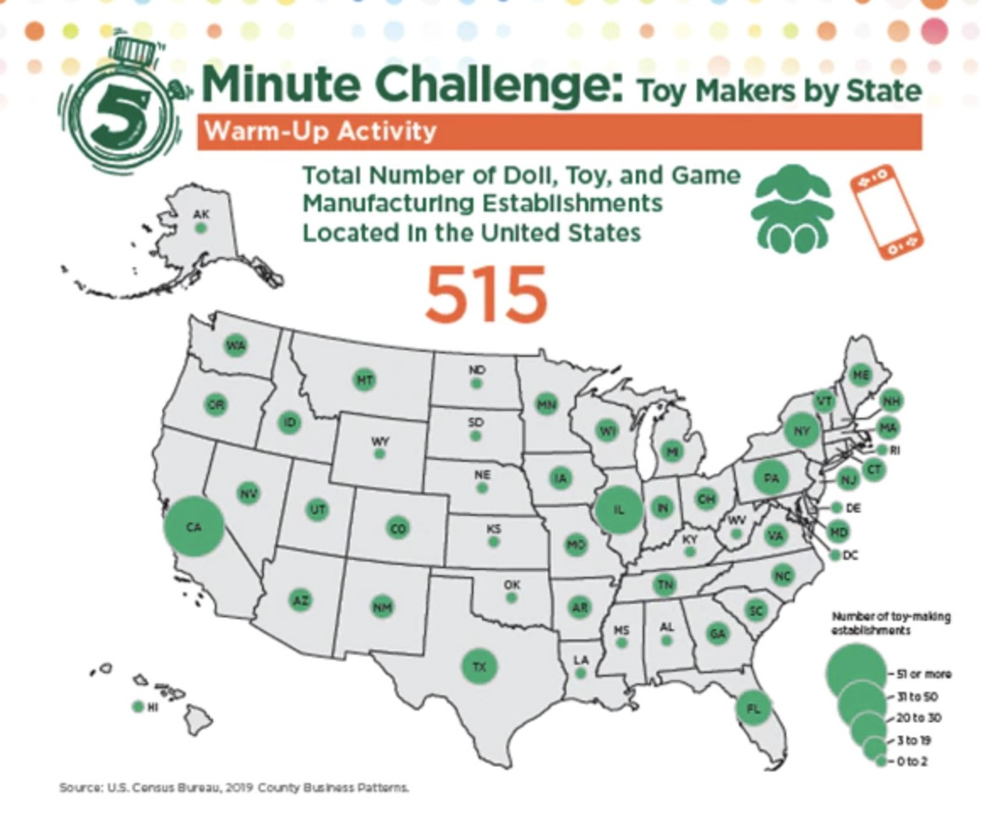
Toy Makers by State | 24 Dysart Schools to participate in Festival of the Arts to showcase visual and | Electrify your symphony! Rock orchestra experience comes to Tucson

